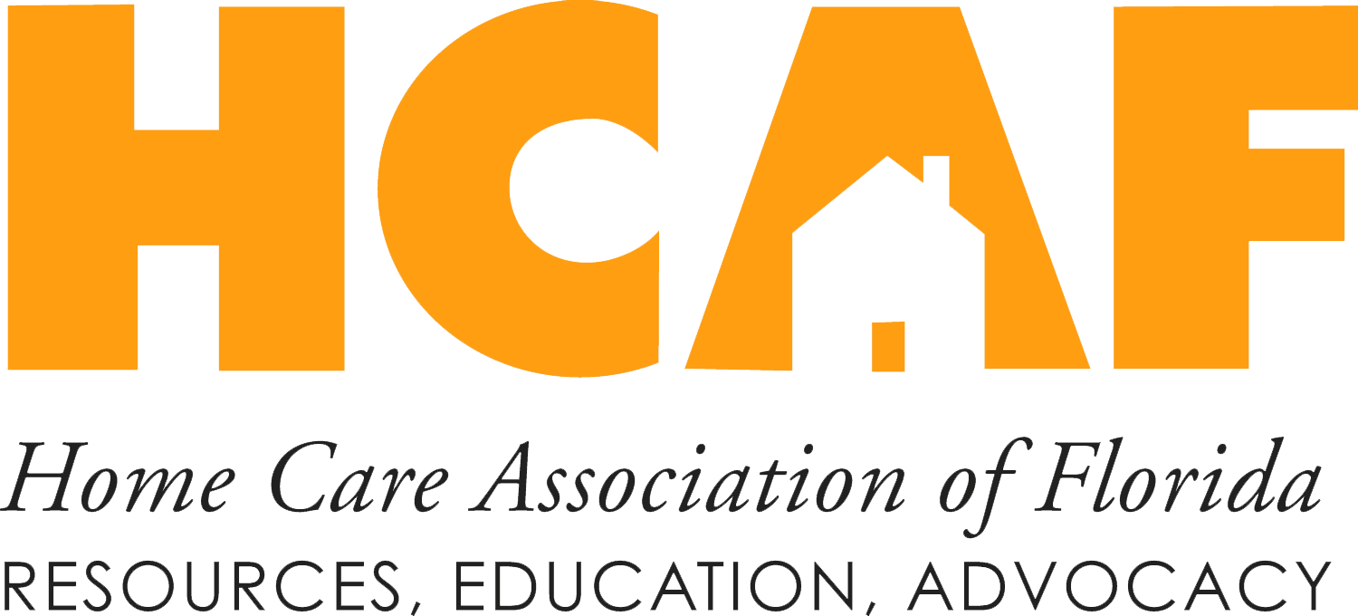
Home Health Administrator’s Webinar Series for Reform Success
4-PART WEBINAR SERIES

In the past few years, Healthcare changes have hit the Home Health industry head on, challenging many long-standing beliefs about delivering care in the home. Most of the reforms aren’t focused directly on Home Health; they are primarily related to Medicare’s rewiring of the Care Continuum in terms of Volume to Value. But the net effect of the IMPACT Act reforms is the revamping of our care production and delivery processes, altering the basic premise of Home Health under the Medicare Prospective Payment System (PPS). By redefining the Home Health identity in terms of positively rewarding rapid outcomes in clinical and fiscal terms, IMPACT Act reforms outline the care path of the future.
Home Health administrators may find the reforms a confusing set of care directives that fail to relate to the home care industry they know. In addition, the reforms don’t necessarily build on the PPS model that directed care for the last 20 years. By rewiring the Home Health model entirely on the clinical acuity (or illness) of an individual patient, IMPACT Act reforms create a model where rapid care outcomes produce improved clinical and fiscal results. The recent Home Health focus on clinical acuity is the basis of additional pending or planned reforms, including the Home Health Value-Based Purchasing (VBP) Model, the Review Choice Demonstration (RCD), and the PPS for post-acute care (PAC) providers.
This progressive, four-part webinar series for Home Health Administrators and Owners addresses Home Health challenges related to IMPACT Act reforms. Learn the effects of specific IMPACT Act reforms, and operational processes that address each reform to produce improved Clinical and Fiscal outcomes. Gain insight into the following areas:
- How the Patient-Driven Groupings Model(PDGM) outcomes can exceed PPS era results
- The why and how of Value-Based care programs
- Addressing the Home Health Culture Change required for success
- How VBP Expansion regulations are the natural enemy of Home Health recertification
- How to employ Outcome and Assessment Information Set (OASIS)-E to better outcomes under the PDGM
- Why the PAC PPS will alter Home Health Utilization for acute care episodes
- How the PAC PPS will modify all Home Health programming
- How to lead your referral sources through the changes
With a Value-Based Home Health platform as the basis of the rewired Acute Care Episode that goes into effect in 2025 under the PAC PPS, now is the time to transition your agency for success. Home Health Providers who successfully complete this transition learn how to replace home care volume practices with real-time clinical management, and they report improved employee satisfaction as a result. Make sure you attend this important webinar series and start your journey on the Value path required for Home Health success today.
Session Overviews
Part 1: Outlining the Value-Based Home Health Landscape: Where Have Impact Reforms Led Us?
Tuesday, December 6, 2022 • 1:00-2:30 PM ET
- Addressing Home Health Reforms from the Administrator’s seat
- A 10,000-foot view of the Post-Acute changes and the effect on Home Health’s legacy
- A demonstration of how traditional Home Health Practices obstruct potential outcomes
- The connection between clinical efficiency and fiscal margins
- The how and why of IMPACT Act Value reform changes
- Preparing for future changes and analyzing specific reforms for operational targets
- Actionable items for IMPACT Act Reforms (i.e., VBP, RCD, OASIS-E, PAC PPS)
- IMPACT Act Value Reform roadmap for success

Part 3: Resolving Home Health Value Programming Concerns Under the OASIS-E
Tuesday, February 7, 2023 • 1:00-2:30 PM ET
- Breaking down the OASIS-E for programming directives
- Analyzing the changes — what is Medicare looking for?
- Connecting OASIS-E Start of Care (SOC) findings to a “LIVE” Plan of Care (POC)
- Assuring the SOC and POC address PDGM programming goals
- Connecting the POC to VBP outcomes
- How to manage Home Health Programs on an In-Episode basis for success (NO MORE CASE CONFERENCES!)
- The effect of Value-Based programming on Managed Care and other payors

Part 2: Care Development, Delivery, and Management Basics for Value Outcomes
Tuesday, January 10, 2023 • 1:00-2:30 PM ET
- Addressing the limitation of Home Health in terms of Value Outcomes
- Subjective insights into the effect of Value-Based reforms on a Volume-Based Industry
- Addressing the Home Health Culture Change required for Value-Based Programs
- Resolving the Home Health Model’s lack of a focus on “Patient-Centeredness”
- Replicating Care Programming control of Acute Care Providers
- Establishing (and following) a Value-Based Skill path
- Case study results from Home Health Providers following a successful Operational rewire
- A demonstration of Start of Care (SOC)/Discharge Home Health Program Development and Management

Part 4: Riding the Value-Based Home Health Operational Model to Successful Programming
Tuesday, March 7, 2023 • 1:00-2:30 PM ET
- Plotting out the changes over the next three years of Home Health Modifications
- Addressing the care requirements of tomorrow with your staff today
- Extending your agency’s RCD and VBP practices for an evolving Home Health model
- Aligning your clinical operations and fiscal returns for Value-Based reforms
- Leading your referral sources to better programs and outcomes
- Marketing your Value-Based Outcomes for PAC PPS systems
- How to connect the Managed Care programming of the future to your operations
- Visualizing and preparing for the next Home Health delivery model
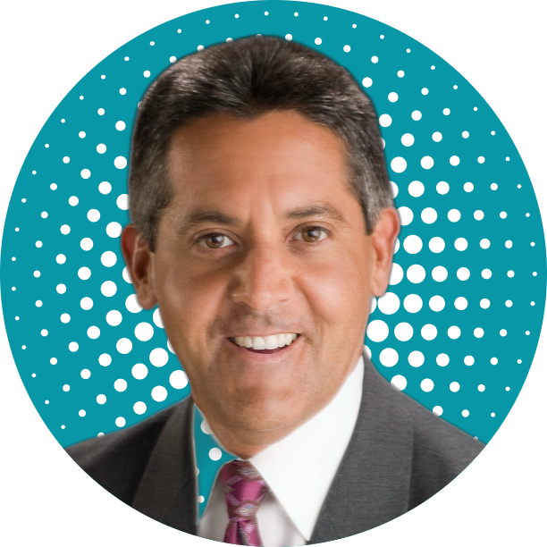
Meet the Speakers
Arnie Cisneros is the President of Home Health Strategic Management (HHSM). He has over 30 years of experience as a Physical Therapist across the care continuum, and he serves as a Post-Acute Consultant for multiple Pioneer Accountable Care Organization (ACO). He is renowned for his adaptation of traditional Healthcare operations to address ongoing Centers for Medicare & Medicaid Services (CMS) reforms.
Kimberly McCormick is a highly accomplished Home Health nurse consultant and the Executive Clinical Director of Home Health Strategic Management (HHSM). With 24 years of Home Health industry experience, including nearly a decade as a Home Health agency Administrator, Kim has the experience and knowledge to provide unrivaled insight into the home care arena. Kimberly served as an Associate Consultant with HHSM, during which she has established herself as an expert in the Utilization Management of Home Health services.
Fees

 | MNCHA Members | Non-Members
Single Program | $49 | $99
Full Series | $149 | $249

