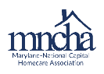

Maryland-National Capital Homecare Association
Home Health Member Meeting
Tuesday, November 16, 2021

- Welcome and Introduce Tammy as Co-Chair Linda Teodosio

- Hot Topics LindaTeodosio/Tammy Rossbach

  - 2022 Final Rule
  - CMS & OSHA vaccination mandates released 11/4/2021 – Review of proposed Final rule & discussion
  - October OASIS Q & A’s review

- Adjourn

